6th Lab – RIP based FLSM Network Topology

IPV4 Subnetting Concept
Rules:
1. Identify network & host requirements
2. Satisfy Network & host requirements
3. Find out Block size
4. Find out network address
5. Find out broadcast address
6. Find out valid host ip address range
7. Find out custom subnet mask & CIDR
Requirements:
IT LAN (60)
MIS LAN (60)
Sales LAN (60)
Class C:
N N N H
192.168.100.0/24
FLSM - Fixed length subnet mask
VLSM - Variable length subnet mask
Network: 2^2 =4
Host: 2^6-2 = 62
Block size: 2^6 = 64
IP Address Allocation Table:
Subnet No. | Network Address(N.A) | Broadcast Address(B.A) | Valid Host IP  (Address Range)
1st | 192.168.100.0 | 192.168.100.63 | 192.168.100.1 - 192.168.100.62
2nd | 192.168.100.64 | 192.168.100.127 | 192.168.100.65 - 192.168.100.126
3rd | 192.168.100.128 | 192.168.100.191 | 192.168.100.129 - 192.168.100.190
4th | 192.168.100.192 | 192.168.100.255 | 192.168.100.193 - 192.168.100.254
Custom Subnet Mask: 255.255.255.192
CIDR: /26

Task:
Subnet the following:
192.168.17.0/24
Network: 5
Host: 30
- Create IP allocation table
- Configure Topology

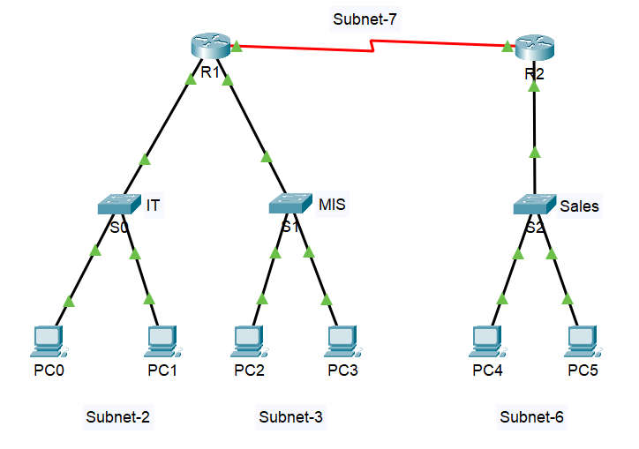
Topology Example:
- IP allocation Table
Network: 5
Host: 30
Address: 192.168.17.0/24

- Solution:
Network: 2³ = 8
Host: 2⁵-2 = 30
Block Size: 2⁵ = 32
Subnet No. | Network Address (N.A) | Broadcast Address (B.A) | Valid Host IP  (Address Range)
1st | 192.168.17.0 | 192.168.17.31 | 192.168.17.01 - 192.168.17.30
2nd | 192.168.17.32 | 192.168.17.63 | 192.168.17.33 - 192.168.17.62
3rd | 192.168.17.64 | 192.168.17.95 | 192.168.17.65 - 192.168.17.94
4th | 192.168.17.96 | 192.168.17.127 | 192.168.17.97 - 192.168.17.126
5th | 192.168.17.128 | 192.168.17.159 | 192.168.17.129 - 192.168.17.158
6th | 192.168.17.160 | 192.168.17.191 | 192.168.17.161 - 192.168.17.190
7th | 192.168.17.192 | 192.168.17.223 | 192.168.17.193 - 192.168.17.222
8th | 192.168.17.224 | 192.168.17.255 | 192.168.17.225 - 192.168.17.254

Table:

Custom Subnet Mask: 255.255.255.224
CIDR: /27

Topology

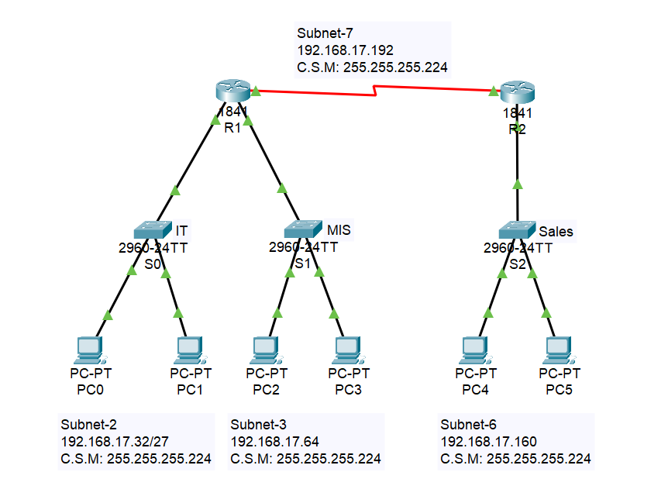

- Network Summary
Switch Name | Subnet | Connected PCs
S0 (IT) | 192.168.17.32/27 | PC0, PC1
S1 (MIS) | 192.168.17.64/27 | PC2, PC3
S2 (Sales) | 192.168.17.160/27 | PC4, PC5
Serial Link | 192.168.17.192/27 | R1 ↔ R2
- Router Configuration (CLI)
Router R1
Router> enable
Router# configure terminal
R1(config)# hostname R1
R1(config)# interface fastethernet 0/0
R1(config-if)# ip address 192.168.17.33 255.255.255.224
R1(config-if)# no shutdown
R1(config-if)# exit
R1(config)# ip dhcp pool IT
R1(dhcp-config)# network 192.168.17.32 255.255.255.224
R1(dhcp-config)# default-router 192.168.17.33
R1(dhcp-config)# exit
R1(config)# interface fastethernet 0/1
R1(config-if)# ip address 192.168.17.65 255.255.255.224
R1(config-if)# no shutdown
R1(config-if)# exit
R1(config)# ip dhcp pool MIS
R1(dhcp-config)# network 192.168.17.64 255.255.255.224
R1(dhcp-config)# default-router 192.168.17.65
R1(dhcp-config)# exit
R1(config)# interface serial 0/0/0
R1(config-if)# ip address 192.168.17.193 255.255.255.224
R1(config-if)# clock rate 148000
R1(config-if)# no shutdown
R1(config-if)# exit
R1(config)# router rip
R1(config-router)# network 192.168.17.32
R1(config-router)# network 192.168.17.64
R1(config-router)# network 192.168.17.192
R1(config-router)# no auto-summary
R1(config)# Ctrl+Z
R1# write

Router R2
Router> enable
Router# configure terminal
R2(config)# hostname R2
R2(config)# interface fastethernet 0/0
R2(config-if)# ip address 192.168.17.161 255.255.255.224
R2(config-if)# no shutdown
R2(config-if)# exit
!--- DHCP Configuration ---
R2(config)# ip dhcp pool Sales
R2(dhcp-config)# network 192.168.17.160 255.255.255.224
R2(dhcp-config)# default-router 192.168.17.161
R2(dhcp-config)# exit
R2(config)# interface serial 0/0/1
R2(config-if)# ip address 192.168.17.194 255.255.255.224
R2(config-if)# no shutdown
R2(config-if)# exit
R2(config)# router rip
R2(config-router)# network 192.168.17.160
R2(config-router)# network 192.168.17.192
R2(config-router)# no auto-summary
R2(config)# Ctrl+Z
R2# write
- PC Configuration (PC0–PC5)
- Click on each PC (e.g., PC0).
- Go to Desktop tab > IP Configuration.
- Select DHCP.
- The PC will receive:
- IP Address
- Subnet Mask
- Default Gateway (from router)

